Lab # 11

Strings in C++

Objective:

The students will learn an apply the
- C-sting
- Declaration and Intilization of C string
- String Object

Introduction
A string is a sequence of characters used to store text. In C++, strings can be handled in two ways:
- Using C-style strings (character arrays)
- Using string objects (from the standard library)
Both methods are useful for storing and manipulating text.

C-Strings
C-strings are arrays of characters that end with a special character called the null character ('\0'). This character shows the end of the string.
Example

Declaration and Initialization of C-Strings
C-strings can be declared and initialized in different ways:
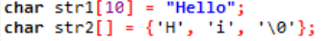
- The size of the array must be enough to store characters and the null character.
- The null character is automatically added when using double quotes.

String Object
C++ provides a built-in string class using the <string> library. It is easier to use than C-strings.
Example:
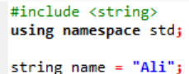
Features:
- No need to worry about size
- Easy to use functions like length, append, etc.

Conclusion
In this lab, we learned about different types of strings in C++. We understood how to declare and initialize C-strings and how to use string objects. String objects are easier and safer to use compared to C-strings.

Lab 11 Tasks
1. String Length Calculation
• Write a C++ program that declares and initializes a string
variable called message with a phrase of your choice.
• Use a built-in function to calculate and display the length of the
String
Code:
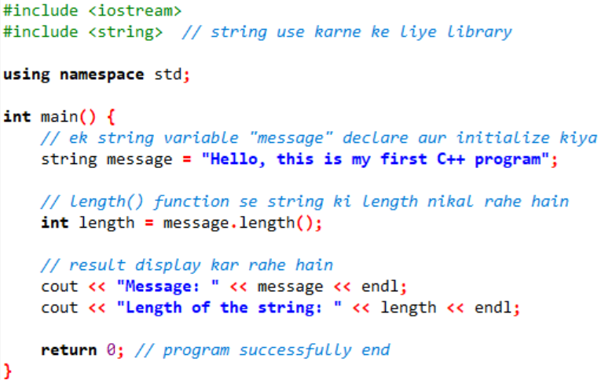

2. String Concatenation
▪ Declare two string variables called firstName and lastName and initialize
them with your first and last name.
▪ Concatenate the two strings to form a full name and display it.
Code:
